**LAB # 06**

**Task # 01: Create a web service of online add to cart system.**

**Solution:**

[WebMethod]

public string AddToCart(string item)

{

return item;

}

**Output:**

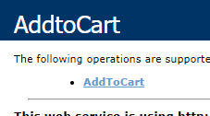

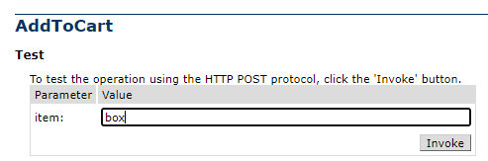

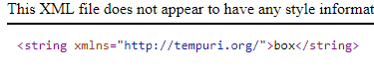

**Task # 02: Create calculator Web Service.**

**Solution:**

public class Calculator : System.Web.Services.WebService

{

[WebMethod]

public double Add(double a, double b)

{

return a + b;

}

[WebMethod]

public double Subtract(double a, double b)

{

return a - b;

}

[WebMethod]

public double Multiply(double a, double b)

{

return a * b;

}

[WebMethod]

public double Divide(double a, double b)

{

return a / b;

}

}

**Output:**

